**My index.html file :**

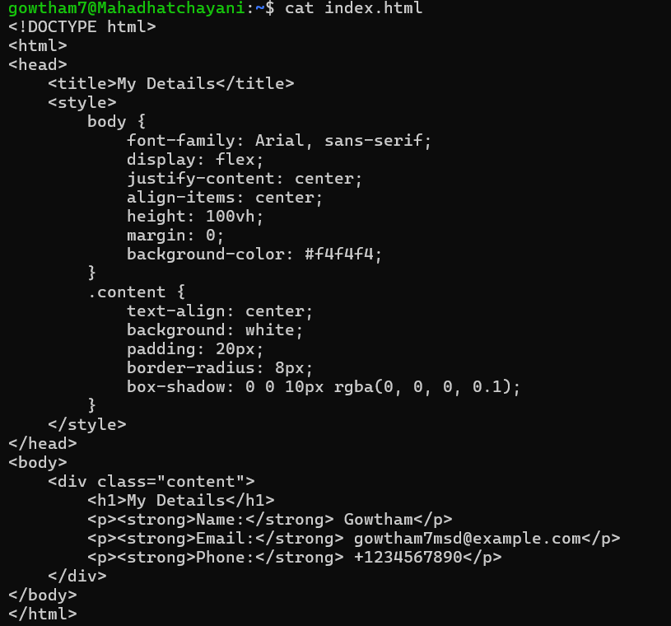

**My Docker File Content:**

**Commands for Docker build and output:**

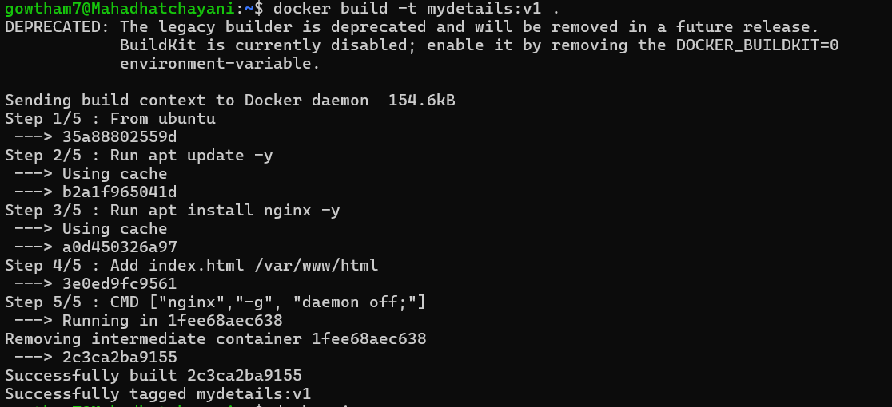

**Docker images:**

**Commands to run the docker image:**



Note: My docker container is running under the port 3003:80 as mybasic name.

**OUTPUT:**

